1. **DATA FAMILIARIZATION AND PARSING**

**File contains**

|  |  |  |  |
| --- | --- | --- | --- |
| **Code** | **Type** | **Wavelength** | **Notes** |
| BT0 | Analog | 532 nm | .o = some polarization |
| BC0 | Photon | 532 nm | .o |
| BT1 | Analog | 532 nm | .p = different pol |
| BC1 | Photon | 532 nm | .p |
| BT2 | Analog | 1064 nm | .o |

* Explored the structure of the Licel LiDAR data files.
* Verified header details, mapped signal columns to channels:
  + 532 nm Analog (BT0)
  + 532 nm Photon (BC0)
  + 532 nm Analog (BT1)
  + 532 nm Photon (BC1)
  + 1064 nm Analog (BT2)
* Purpose: To ensure data was interpreted and processed correctly before analysis.

**2. RAW PROFILE PLOTTING**

* Plotted raw backscatter profiles for all channels combined (log scale).
* Plotted individual channel profiles (linear scale).
* Purpose: To observe if any vertical variations or wave-like structures were present in the raw data.

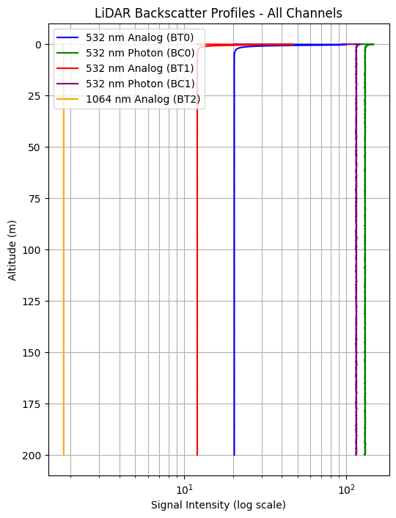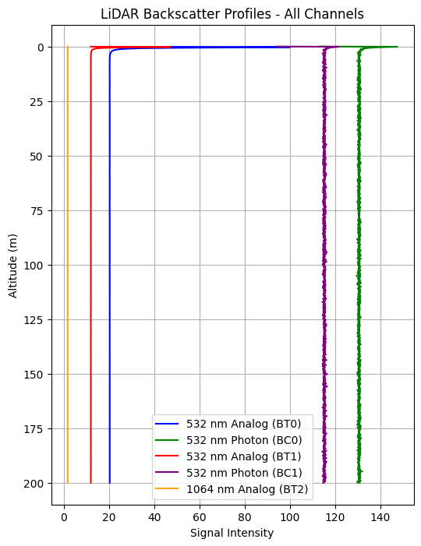**Image 1: Raw backscatter profiles (all channels, log scale)**

**Image 2: Separate channel raw profiles (linear scale)**

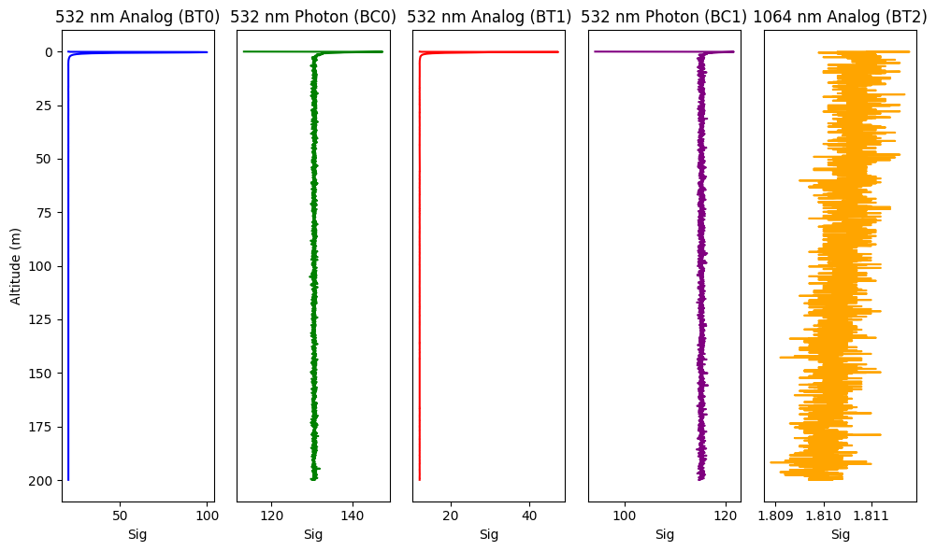

**Observation:**

* Profiles appeared nearly vertical, with constant signal intensity at different altitudes (0–200 m). No wave-like patterns were visible.

**3. SMOOTHING USING MOVING AVERAGE**

* Applied moving average smoothing on each channel’s vertical profile.
* Purpose: To reduce noise and reveal any small-scale fluctuations that could indicate hidden wave patterns.

**Image 3: Smoothed backscatter profiles (all channels)**

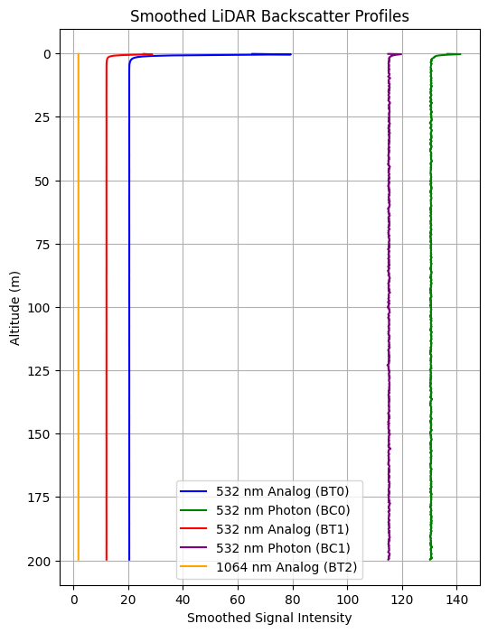

**Observation:**

* Smoothing did not reveal any new features. The profiles remained flat without noticeable vertical variations.

**4. TIME-AVERAGING OF PROFILES**

* Averaged multiple profiles across different files to compute time-mean profiles.
* Purpose: To enhance persistent features by reducing random fluctuations.

**Image 4: Time-averaged backscatter profiles (all channels)**

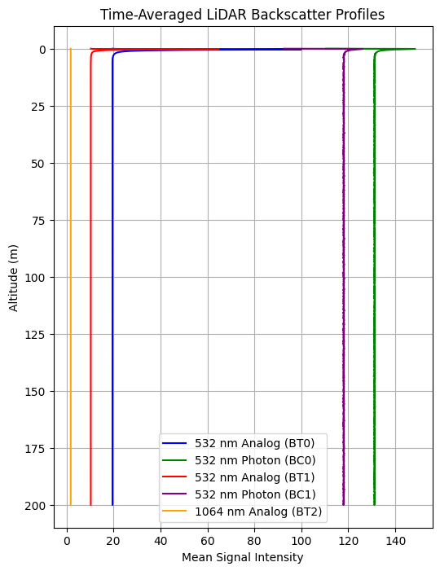

**Observation:**

* Time-averaged profiles were consistent with individual profiles. No vertical wave patterns were detected.

**5. FREQUENCY DOMAIN ANALYSIS (FFT)**

* Applied Fast Fourier Transform (FFT) to vertical profiles of each channel.
* Purpose: To detect dominant vertical frequency components that might indicate wave structures not visible in profile plots.

**Image 5: FFT vertical frequency spectrum (all channels)**

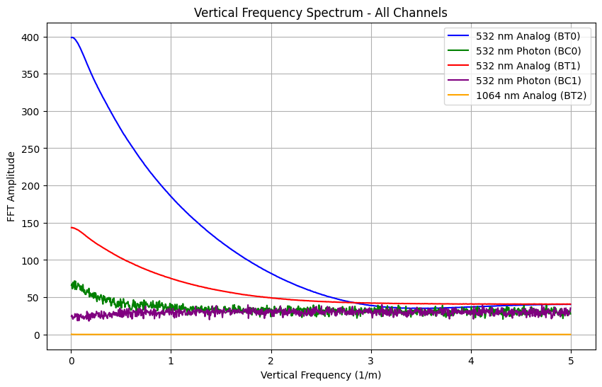

**Observation:**

* FFT showed strong low-frequency (DC) components due to flat signal. No sharp peaks at higher frequencies were detected, indicating absence of vertical periodicity.

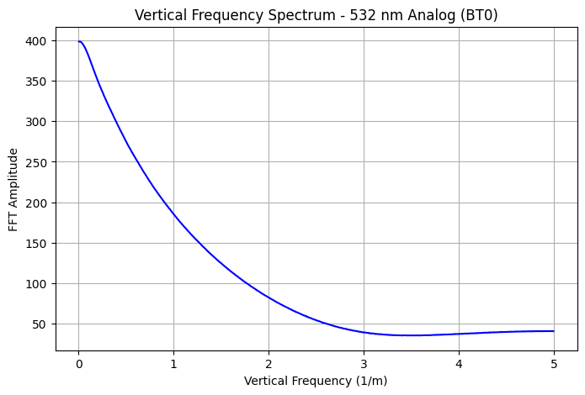

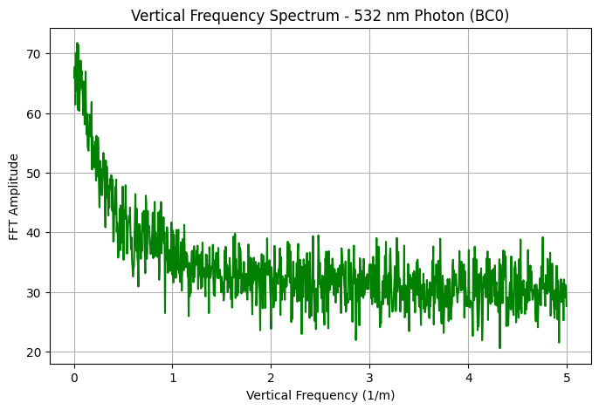

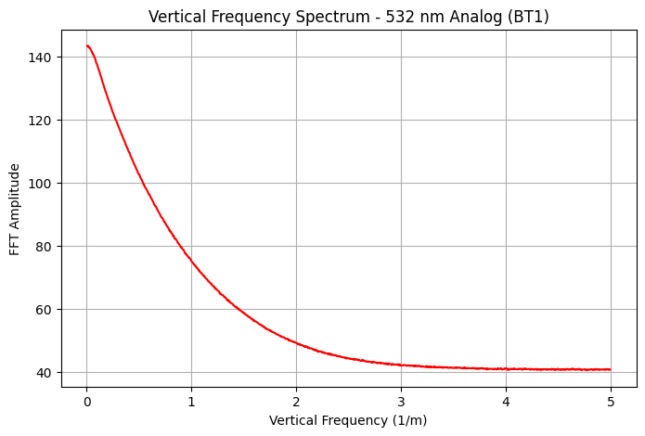

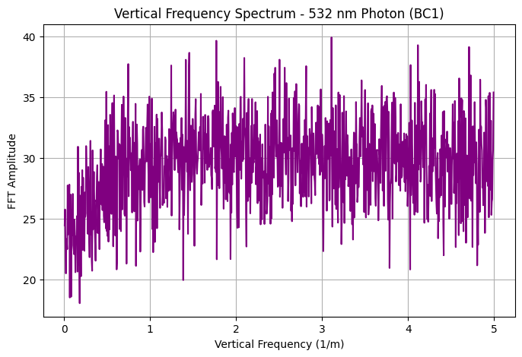

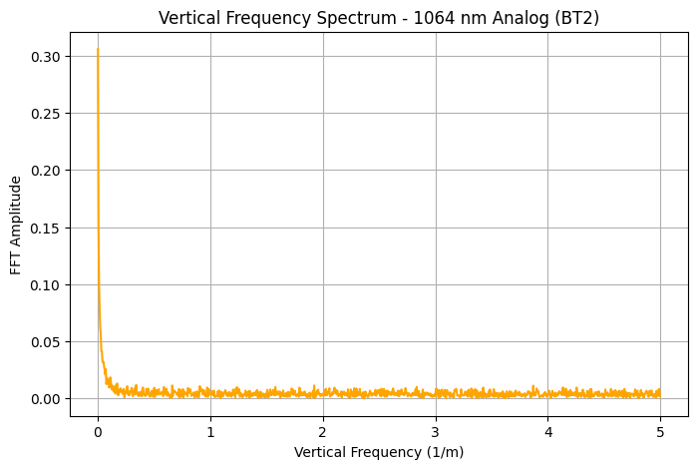

**6. BATCH PLOTTING AND CONSISTENCY CHECK**

* Plotted profiles from multiple files for comparison.
* Purpose: To confirm consistency across time and ensure no features were missed.

**Observation:**

* Profiles were consistent across files. No significant variation was observed.

**SUMMARY OF WORK**

* Data structure was explored and signal channels correctly identified.
* Raw profiles plotted and inspected; no wave-like structures found.
* Smoothing and time-averaging applied; no hidden structures detected.
* FFT applied; no dominant vertical frequency components detected.
* Batch consistency checks confirmed stable profiles over time.